**Group Project**

Title

**Blackjack**

Course

**CIS-17B**

Section

**47340**

Due Date

**December 13, 2017**

Authors

**Kevin Vo**

**Yating Ge**

**Trevor Shortlidge**

**Kevin Romeo**

**Roles:**

Yating Ge – She is in charge of CSS, the dynamic aspect of the page such as having the playing cards appear along with its card animation and functions for the buttons in Javascript.

Kevin Vo – Designed the layout of the game, rules page, and leaderboard that communicates with the database to obtain usernames and balance, implemented local storage for balance so the game will remember it after refreshing, and constructing write-up.

Trevor Shortlidge – Implemented the use of JS object -> cookie -> PHP object along with a login/admin page.

Kevin Romeo – Converted his C++ code into Javascript and imported Dr. Lehr’s deck.

**Note:**

Dear Dr. Lehr:

We were unable to transition our project into your server since we couldn’t find our appropriate folder “TeamBlackjack”. We have tried making another account under the same name (“TeamBlackjack”) but it was stated that an account with that name has already been taken as we have already made the account earlier during this semester.

Sorry for the inconvenience,

The Group

**Group Status Report:**

Yating, Trevor, and Kevin tried contacting the rest of our members but received neither text nor calls. Kevin Vo was assigned to do the main layout of the pages, which includes the UI, results, rules, and leaderboards pages that operates with a database. He coded the leaderboard to work with a database that ascends and descends the content within the table which again works with a database but only under localhost. Trevor was in charge of the admin and login pages while Yating was working on dynamic aspects of the game like animation along with the CSS. Kevin Romeo did a lot of the game mechanic as he converted his C++ code into Javascript which had some bugs that we weren’t able to fix. We tried contacting him on his code but he did not answer our calls and texts. Mario was the same as we tried contacting him as well since he was in charge of the database a couple of weeks prior but was unable to reach him within the last week. Therefore, we couldn’t complete a few of the tasks at hand and that’s why we came to you. As for Bryan Nguyen, he informed us many months prior that he had dropped the class on Oct. 25th; while we’re unsure of Ricardo D.’s status as he was unresponsive to our group texts since Oct. 26th.

**Requirements Checklist:**

1. ***MVC - How you delineated your objects***

**Line 304 to 309 in blackjack.php**

* 1. Had an object for:
     1. Shoe
     2. Dealer
     3. Player
     4. Card
     5. Save/Load
     6. Hand

1. ***Objects - Javascript/PHP – Serialization Passing info with Javascript Objects to PHP Objects with Cookies***

**“Serialization Passing info with Javascript Objects”**

**Line 38 in save_load_game.js**

setCookie("balance",v * 1,1);

**“…to PHP Objects with Cookies”**

**Line 12 & 13 in blackjack.php**

$username = $_COOKIE['username'];

$balance = $_COOKIE['balance'];

1. ***Reading/Writing Files/Local Storage JSON – Javascript***

***Line 11-14, 32-34, 53–54 in save_load_game.js***

this.balance = JSON.parse(localStorage.getItem("objBalance"));

if (this.balance === null) {

this.balance = [];

}

localStorage.setItem("objHand", JSON.stringify(this.aHand));

localStorage.setItem("objBalance", JSON.stringify(this.balance));

var v = localStorage.getItem("objBalance");

this.balance = JSON.parse(localStorage.getItem("objBalance"));

var v = localStorage.getItem("objBalance");

getCookie("balance",v,1);

1. ***Databases SQL - Identify Entities, Xref, and Enum Tables***

* Sorry, we only have 2 operational entity tables and felt that x-ref and enum tables were unnecessary.

1. ***Form Validation - Reqular Expressions***

***Line 52 in getForm.php & Line 52 in getAdminForm.php***

pattern="(?=.*\d)(?=.*[a-z])(?=.*[A-Z]).{8,}"

***6) User-Admin-Login***

AdminAccess.php ***<- for admin***

adminLogin.php

Access.php ***<- for user***

Login.php

***7) Cookies - Sessions - Securing Pages***

***One example is in Line 2 – 36 in getAdminForm.php***

***Session_destroy is in logout.php line 4***

**Description:**

This project is a videogame representation of a real life Blackjack where the player plays against the house and tries to win a hand that is as close to 21 as possible while not exceeding 21. The player has an option of hit, double, stand, and replay throughout the game. In the end it will store their login information including the earnings so they can return and play with the same balance.

**Rules:**

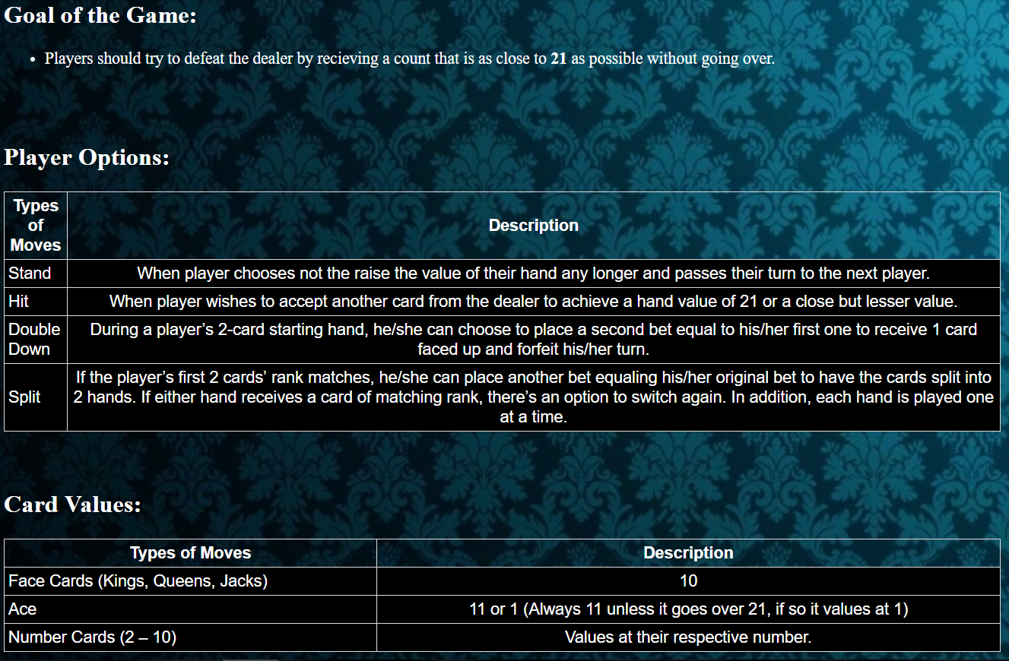

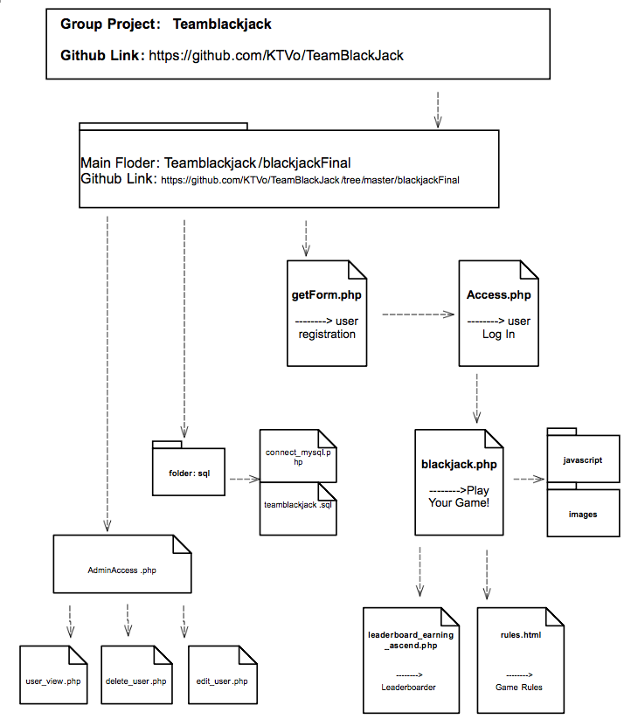**Diagram-UML:**

**Screen Shots (interact with the game in this order):**

**getForm.php**

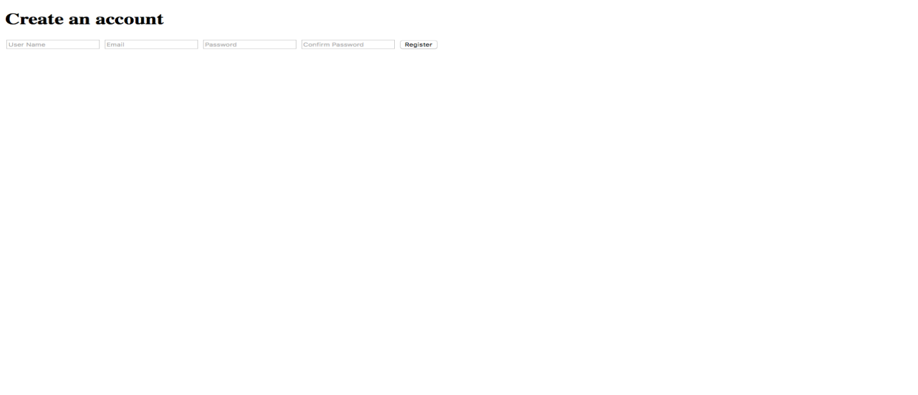

**Access.php**



**blackjack.php**

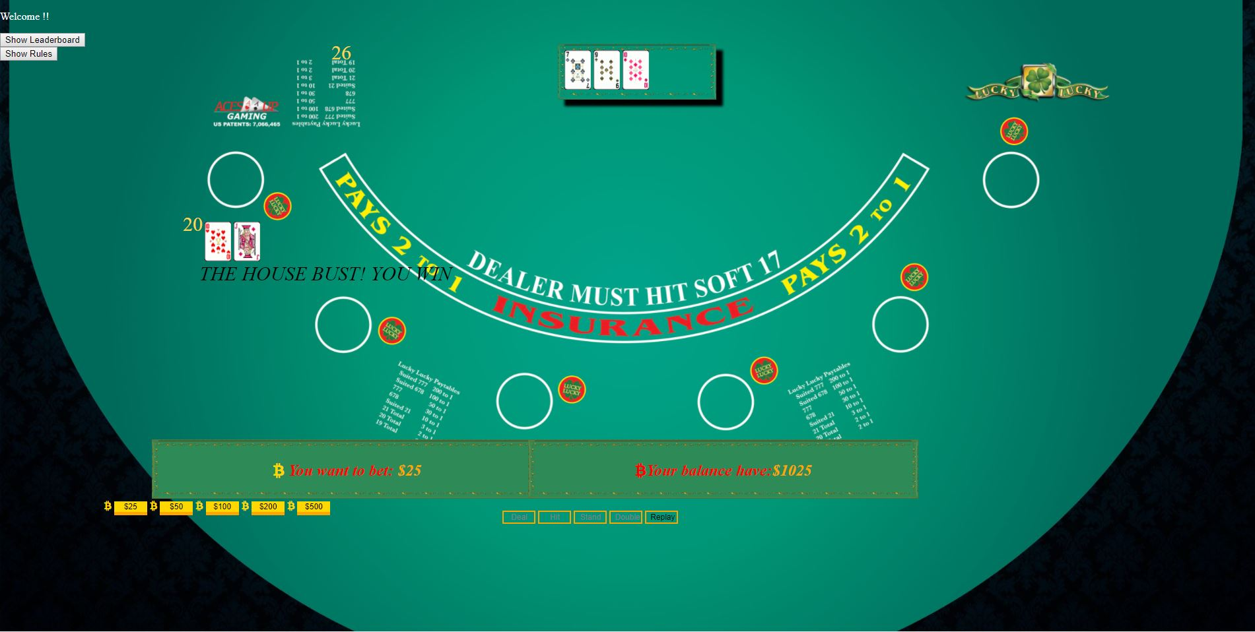

**leaderboard_earning_ascend.php**

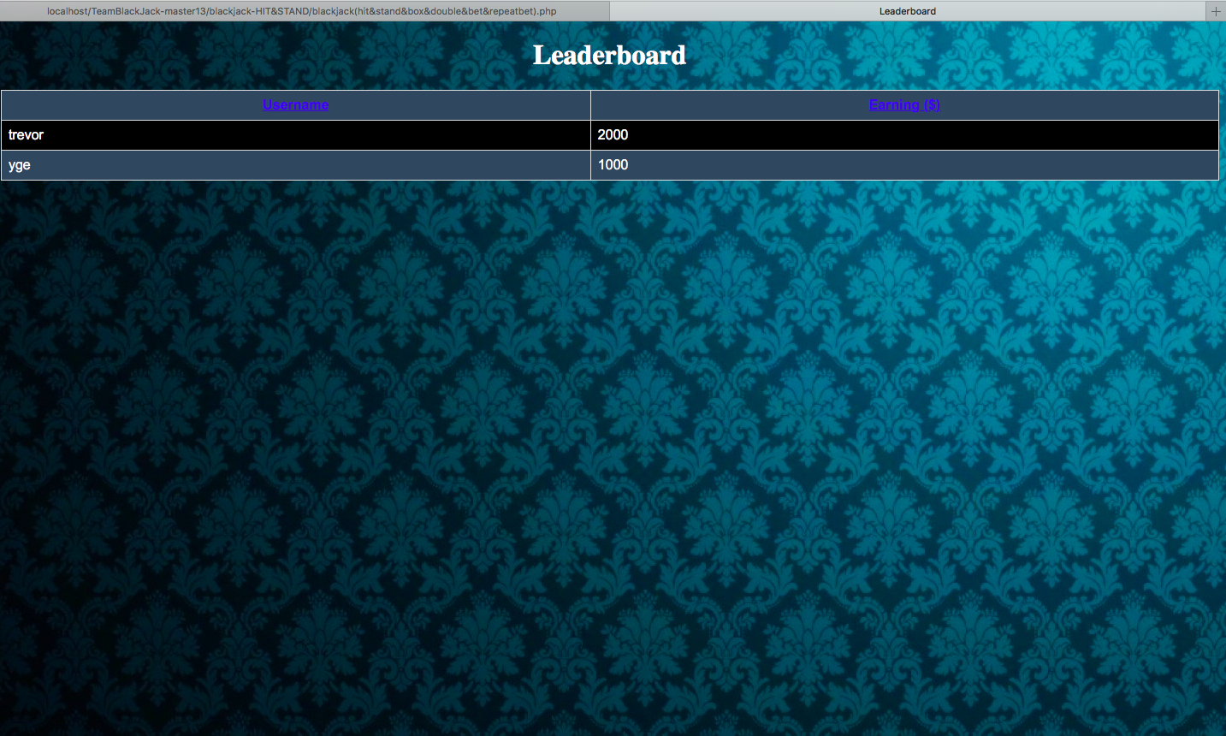

**Database:**

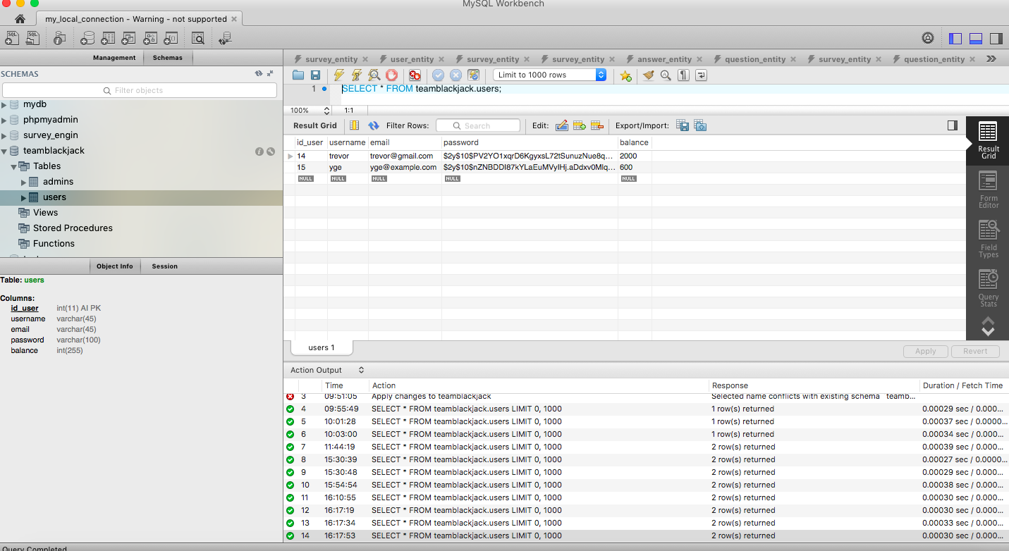

**Code (Not the entire program):**

**leaderboard_earning_ascend.php: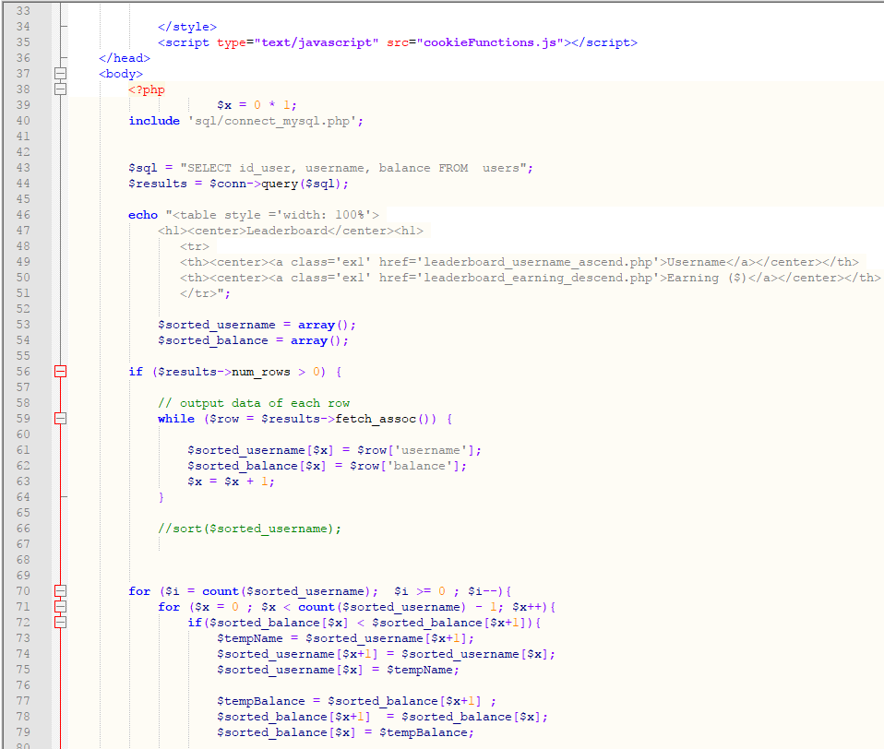blackjack.php**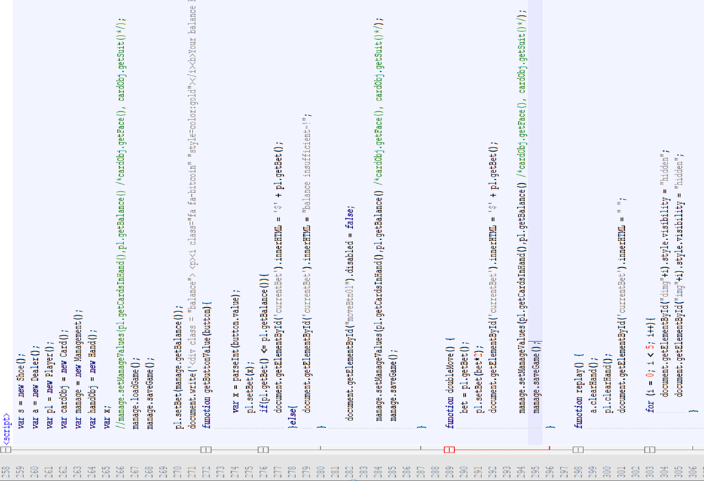

**save_load_game.js:**

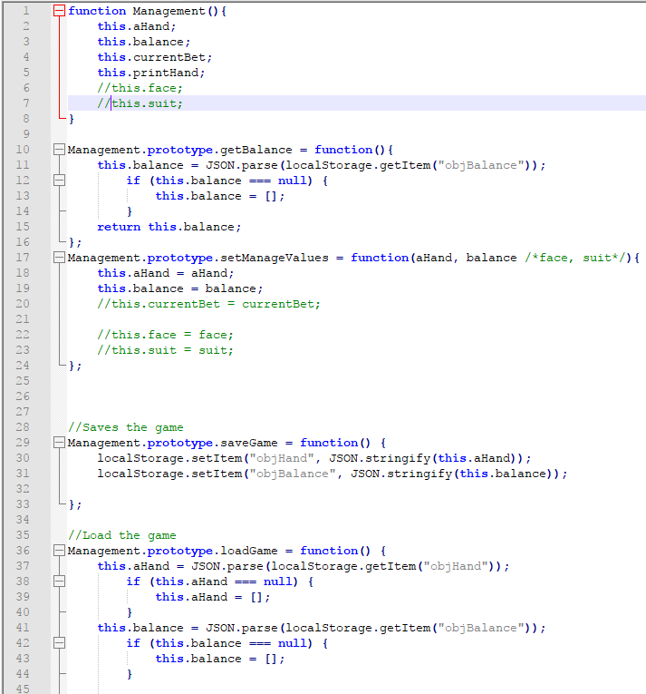

**hitMove.js**

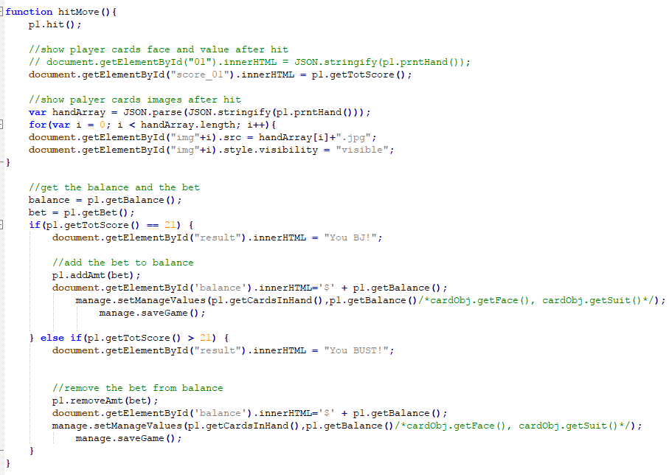

**getAdminForm.php**

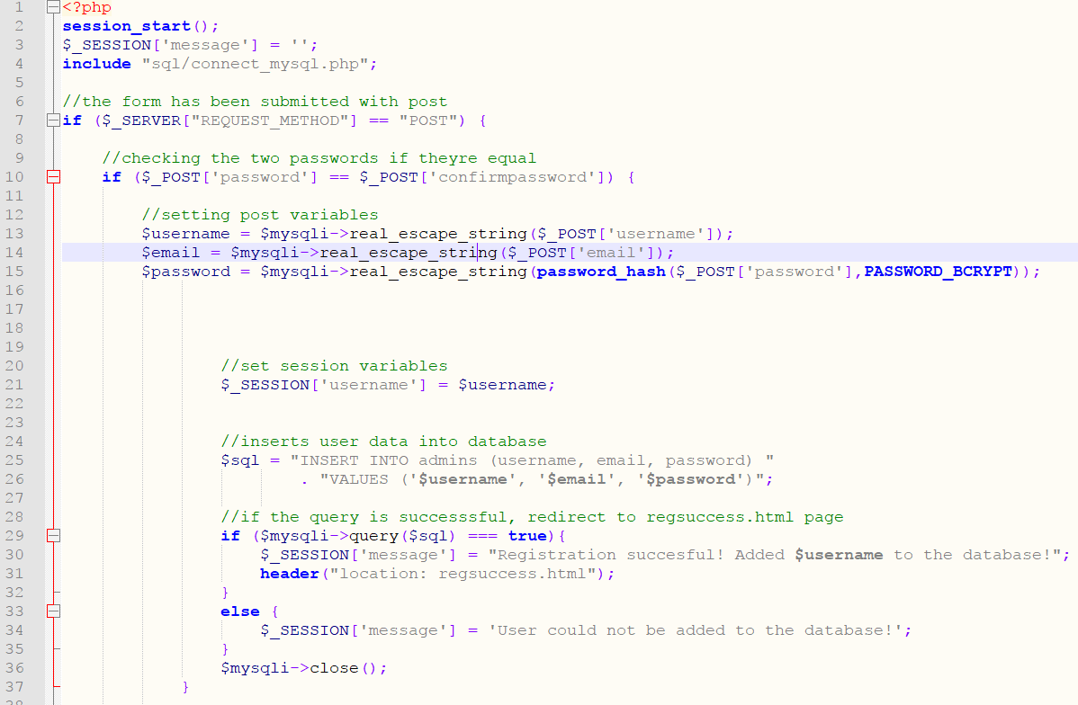

**Github Link:**

**https://github.com/KTVo/TeamBlackJack/tree/master/blackjackFinal**